
Keshet’s 2026 Winter Concert
Student Information Sheet (ages 9-Adult)

- When? Thursday December 10th at 6:30pm and Friday December 11th and 6:30pm
- Where? Keshet Dance and Center for the Arts Black Box Theater
- There are two ways to participate in Keshet’s Winter Concert:
- Keshet Class:
  - Talk to your teacher to see if your class is creating a piece.
  - Review the Tech schedule below to ensure you are able to attend ALL Dress Rehearsals and Shows.
  - Scan the QR code below (or on the call board) to submit the ONLINE participation form by November 21st.
2. Student Choreography: Submitting one piece of your own choreography
- Review the Tech schedule below to ensure you are able to attend ALL Dress Rehearsals and Shows.
- Scan the QR code below to submit the ONLINE Choreography Submission Form by October 31st.

Tech Rehearsal/Performance Schedule
You must be able to attend ALL rehearsals and performances.

Tuesday, December 8th:
5:00-5:30 pm – Costume Call (only if you need to borrow a Keshet costume)
5:30 pm-8:30 pm – Tech and Dress Rehearsal
Wednesday, December 9th:
5:30 pm-8:30 pm – Final Tech and Dress Rehearsal
Thursday, December 10th:
5:00 pm – Optional Warm Up
5:30 pm – Dancer call
6:30 pm – Performance
Friday, December 11th:
5:00 pm – Optional Warm Up
5:30 pm – Dancer call
6:30 pm – Performance
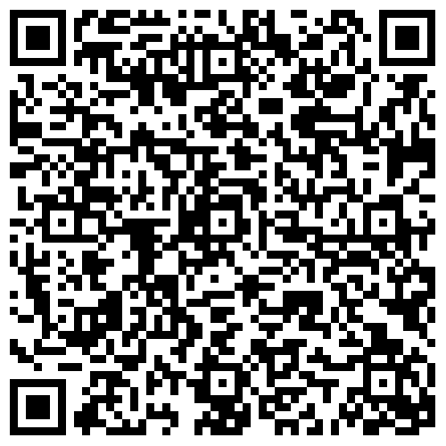
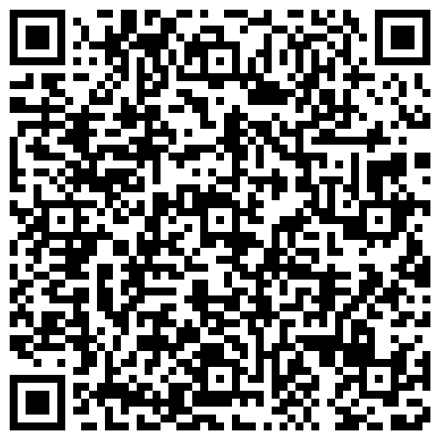
Reach out to Laura Orozco Garrett at Laura@KeshetArts.org if you have any questions.

The costume for your class will be posted on the call board and emailed to the student/student’s family. Please watch your email for important updates and reminders.
Purchasing items for your costume is not expected. Keshet has what you need! More costume notes below.
Other Important Winter Concert info: TECH DETAILS

Please pack:
- Costume: Bring costume to the first day of Tech rehearsal to leave at Keshet through the final performance. Hair should be neatly pulled back, jewelry should not be worn, no fingernail or toenail polish. Keshet has limited costumes available to borrow for the duration of tech week and performances. If you would like to borrow a costume item that is requested by your teacher, please attend the costume call listed on the performance schedule. If you have any costume inquiries (ex: if you need to figure out if the item you need is in our inventory), please reach out to Diana at costumes@keshetarts.org.
- Scent-Free Dressing Rooms: Please refrain from wearing any scented personal care products to keep a safe space for all dancers.
- Snacks and a Water Bottle: A microwave is available for students and breaks will be provided. Please refrain from bringing peanuts due to allergies and avoid messy food.
- Quiet Activity: Feel free to bring a quiet activity to engage in when dancers are not on stage. Backstage is a technology free zone. Ideas include: books, playing cards, colored pencils, etc.
Notes for the performance:
- Multi-Generational Dressing Rooms: Dressing rooms backstage are an opportunity for mentorship and learning new things from dancers of ALL AGES. Performers will be assigned to a dressing room paired with performers of varying ages. This is a great way to meet, mentor, and connect with other dancers in the Keshet community.
- Tickets: Tickets go on sale on November 9th, 2026. Tickets may be purchased either in person at the Keshet Box Office or online (keshetarts.org). All tickets are on a sliding scale and all proceeds benefit the Keshet Dance Scholarship fund. Questions? Email boxoffice@keshetarts.org.
- Backstage: Parents/Guardians and family members are NOT allowed backstage. Dancers will be supported by Keshet staff. Please plan on picking up your dancer at the performance in the Bay Area adjacent to the theater.
Please expect email reminders with important information. If at any time questions or concerns arise please let us know at the front desk or reach out to Laura (Laura@KeshetArts.org). We are so excited to have you/your student to dance with us!

